

Significant people

* Will Smith
* The Beatles
* Santana
* A. R. Rahmen

Knowledge/ Skills

* Pupils will listen and appraise Classical music
* Pupils will consider the language of music
* Continue to embed the foundations of the interrelated dimensions of music using voices and instruments
* Sing
* Play instruments with a range of songs
* Improvisation using voices and instruments
* Develop further composition skills
* Share and perform the learning that has taken place

National Curriculum

Pupils will listen with attention to detail, recall sounds with increasing aural memory, use and understand staff and musical notations, appreciate live and recorded, music from different composers and famous musicians and play instruments with increasing accuracy, fluency, control and expression.

Prior learning

This will consolidates the learning that has occurred during the year. All the learning is focused around revisiting songs and musical activities, a context for the History of Music and the beginnings of the Language of Music.

Vocabulary and definitions

|  |  |
| --- | --- |
| Word | Definition |
| Instrument | a device created or adapted to make musical sounds |
| Pulse | the regular heartbeat of the music; its steady beat |
| Rhythm | long and short sounds or patterns that happen over the pulse |
| Pitch | high and low sounds |
| Tempo | the speed of the music; fast or slow or in-between |
| Compose | the act of writing songs or creating a piece of music |

Pictures/ timelines/ map/ diagrams

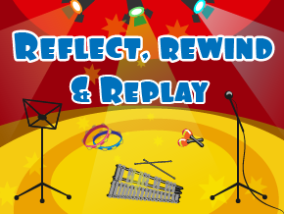

Unit of work

Charanga – Reflect, Rewind and Replay Summer 2

Year group

1

Eaton Primary School

*Music*

Knowledge Organiser