

Vocabulary and definitions

|  |  |
| --- | --- |
| Word | Definition |
| century | A period of 100 years. |
| coast | An area of land next to a sea. |
| dinosaur | Large reptiles that lived in prehistoric time that are now extinct. |
| discovery | When someone finds something for the very first time. |
| extinct | No longer has any living members (none of it are left). |
| fossil | The hard remains of a prehistoric animal or plant that are found inside a rock. |
| influential | Something or someone very important. |
| prehistoric | The time in history before any information was written down. |
| reptile | A group of cold-blooded animals that lay eggs and have scaly skin e.g. snakes, lizards and crocodiles. |
| scientist | Someone who studies science and whose job is to teach or research science. |
| skeleton | The framework of bones in a body |
| vertebrate | A creature which has a spine (a backbone). |

Pictures/ timelines/ map/ diagrams

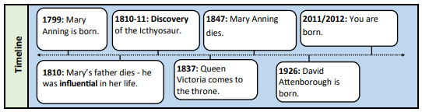

Knowledge/ Skills

Mary Anning was a famous English fossil hunter.

• She was born in 1799 and lived in Lyme Regis by the coast near the English Channel. This coast is called the Jurassic Coast.

• She was one of ten children but only she and her brother, Joseph were the only children to survive to adulthood.

• Dinosaurs existed millions of years ago - before humans lived on Earth. They are now extinct. When they became extinct, their remains were left behind as fossils.

• Mary’s father taught her how to get the fossils out of the rock by using a hammer and chisel. Mary would then sell the fossils to help support her family.

• Mary then met Elizabeth Philpot, who was a fossil expert. She saw Mary’s fossils and taught her about what fossils were by giving her books to read.

• Around 1810-1811, Mary made an amazing discovery. She had found a giant fossil that no one had ever seen before. It was the skull of a giant creature that looked like a crocodile. She had found the first complete fossil of an Ichthyosaurus.

• Mary Anning is often referred to as one of the first palaeontologists – scientists who study fossils – and her work started to change our understanding of how the world has changed over time.

• Her work and discoveries can now be seen in the Natural History Museum in London

Unit of work

Lives of significant others – Mary Anning

Year group

1

Significant people

Compare to David Attenborough

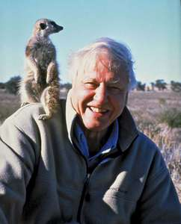

National Curriculum

Pupils should be taught the lives of significant individuals in the past who have contributed to national achievements.

Prior learning

Mary Seacole lived in the 19th century - this was around the same time as Mary Anning. • The United Kingdom has a coastline by the English Channel. • Reptiles are one of the five types of vertebrates. • The four compass points • A town is a large group of houses, shops and buildings where people live and work. Towns are larger than villages but smaller than cities. Sudbury is a town.

Eaton Primary School

*History*

Knowledge Organiser