Prior learning

* Children have learnt about various fairytales.
* Children have learnt about colours in art.
* Children have learn about some artists including Jackson Pollock.

National Curriculum

* to develop a wide range of art and design techniques in using colour, pattern, texture, line, shape, form and space

## about the work of a range of artists, craft makers and designers



Unit of work

Fairytale/ Collage

Year group

1 – Aut 2

Eaton Primary School

Art

Knowledge Organiser

Vocabulary and definitions

|  |  |
| --- | --- |
| Word | Definition |
| Texture | The surface quality in a piece of work. Something can be an actual texture (feel like it is 2D or 3D) or an implied texture (look like it feels like something). |
| Artist | A person who creates paintings, drawings and sculptures. |
| Pattern | A pattern is a design which is repeated. |
| Line | A line is an identifiable path created by a point moving in space. Lines can be horizontal, vertical, or diagonal, straight or curved, thick or thin. |
| Geometric shape | Shapes we can name e.g. triangle, square, circle |
| Organic shape | A shape we cannot give a name to. These shapes are often found in the natural world. |
| Primary colours | Yellow, red and blue. These colours cannot be mixed from other colours. |
| Secondary colours | Green, orange, purple. These colours can be created by mixing two of the primary colours. |
| Complementary colours | Any two colours which are opposite each other on the colour wheel, for example, yellow and purple. |

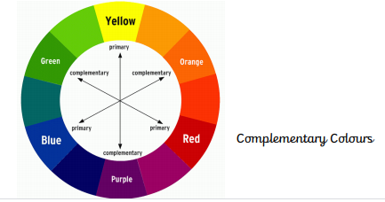

Henri Matisse (1869 – 3 November 1954)

French artist known for his use of colour and original ideas. He painted from life and his work includes many portraits (links later to self-portraits). He had a great impact on future artists like Jackson Pollock and Georgia O’Keeffe. During the last decade of his life Henri Matisse deployed two simple materials—white paper and gouache—to create works of wide-ranging color and complexity. An unorthodox implement, a pair of scissors, was the tool Matisse used to transform paint and paper into a world of plants, animals, figures, and shapes.

Knowledge/ Skills

Children will learn about various fairytales and collage techniques. Children will also reflect on artists which have created collage. Focusing on: Matisse.

Children will understand how to use texture, shape and colour to create their own collage based on the working of Matisse.

Creative Thinking skills- Children can be creative in the way that they create their collage. They can use their own ideas and their own choice in colours etc. Children have freedom to experiment with skills, techniques and colour mixing.

Reasoning skills- Children will be looking at other artists work. They will be able to reason why they like and don’t like others work, and give reasons for this. They will be experimenting with different techniques and will decide which ones to use in their final self-portrait.

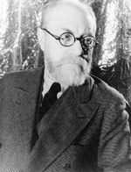

Pictures/ Links

<https://www.moma.org/interactives/exhibitions/2014/matisse/the-cut-outs.html>

