****

Vocabulary and definitions

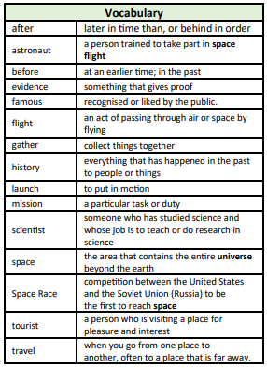

Unit of work

Changes within living memory – Man on the moon

Year group

1

Pictures/ timelines/ map/ diagrams

Significant people

Yuri Gagarin

Valentina Tereshkova

Neil Armstrong

Buzz Aldrin

Helen Sharman

Tim Peake

National Curriculum

Changes in living memory, and the lives of significant individuals in the past who have contributed to international achievements.

Prior learning

Things happened before I was born.

• Things happened before my parents and grandparents were born.

• Life is different now to how it was when my grandparents were children.

• What the moon is.

Knowledge/ Skills

• Place key events in the history of space travel on a timeline.

• Compare this timeline to the timeline of your family - where do key events in your family’s life cross over with key events in space travel?

• Choose two astronauts to compare. Where are they from? What were their achievements? What are their similarities and differences?

• Explain what caused the 1969 Moon Landing.

• Explain what effects the 1969 Moon Landing had on history.

• Use words such as before, after, past, present, then and now to describe the history of space travel.

• Before the Apollo 11 flight mission, people had been in space as part of the Space Race but had not yet been to the moon

. • This was to be the next step in space travel

• On July 16th 1969, Saturn 5, was launched. There were three American astronauts on board; Neil Armstrong, Buzz Aldrin and Michael Collins.

• It took four days to reach the moon.

• Neil Armstrong was the first man on the moon - 19 minutes after Buzz Aldrin joined him.

• They gathered moon dirt and rocks to bring back to Earth.

• They also took photographs to show what the moon was like.

• The moon landing was important because it told us that people could travel there and back safely. It would also help us find out more about space and the moon.

• Neil Armstrong famously said, “One small step for man, one giant step for mankind.”

Eaton Primary School

*History*

Knowledge Organiser

