

Knowledge/ Skills

* Y1 will start with the children’s immediate experiences – the geography of the classroom, Eaton’s school building and the playground
* The children need to see it and be in it to understand it. This will give them a form of understanding of their local area and will provide a great context for mapping skills
* Mapping skills will support learning about plants and animals in the local area.
* This links with science e.g. which trees and plants they are looking at, where the park is
* They will create simple maps of their environment (classroom/playground etc.) before moving on to the immediate local area (Eaton)
* The children will move out to the local area that the children can walk around and explore
* They will look at human and physical features
* they will look at pictures and maps from ‘then and now’

Significant people

Queen Elizabeth II, Victoria 1 and Elizabeth 1

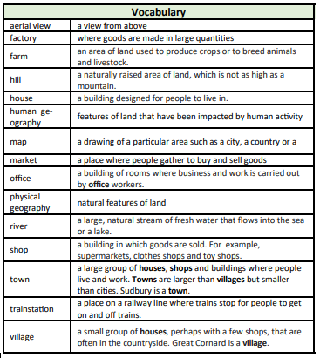

Prior learning

* Eaton is where our primary school is
* Directional language like up, down, left and right
* Simple maps (like a treasure map)
* Eaton is in England
* We have a queen called Elizabeth

Unit of work

**Where can Penguin go and who can he visit?**

Year group

1

<https://www.bgs.ac.uk/igeology/onTheRocks.html> useful website for looking at difference beaches/coasts with different geological features

<https://www.bbc.co.uk/news/science-environment-29572008> useful website for different geographical regions/features within the UK

<https://www.ordnancesurvey.co.uk/mapzone> great website child friendly geography

<https://world-geography-games.com/>

great online games for children to play locating UK countries capital cities

National Curriculum

Pupils should develop knowledge about the world, the United Kingdom and their locality.

The lives of significant individuals in the past who have contributed to national and international achievements.

Eaton Primary School

*Geography*

Knowledge Organiser