

Vocabulary and definitions

|  |  |
| --- | --- |
| Word | Definition |
| backbone | the column of small [linked](https://www.collinsdictionary.com/dictionary/english/link) [bones](https://www.collinsdictionary.com/dictionary/english/bone) down  [the middle of](https://www.collinsdictionary.com/dictionary/english/middle) your back |
| carnivores | an animal that eats meat |
| cold-blooded | a body temperature that changes  [according](https://www.collinsdictionary.com/dictionary/english/accord) to the surrounding temperature |
| environment | all the [circumstances,](https://www.collinsdictionary.com/dictionary/english/circumstance) people, things, and  events around them that influence their  life |
| farm | an area of land used to produce crops or to breed animals and livestock |
| gills | the organs on the sides of fish and other  water [creatures](https://www.collinsdictionary.com/dictionary/english/creature) through which they  [breathe](https://www.collinsdictionary.com/dictionary/english/breathe) |
| herbivore | an animal that only [eats](https://www.collinsdictionary.com/dictionary/english/eat) plants |
| invertebrate | a [creature](https://www.collinsdictionary.com/dictionary/english/creature) that does not have a [spine,](https://www.collinsdictionary.com/dictionary/english/spine)  for [example](https://www.collinsdictionary.com/dictionary/english/example) an insect, a [worm,](https://www.collinsdictionary.com/dictionary/english/worm) or an  [octopus](https://www.collinsdictionary.com/dictionary/english/octopus) |
| omnivore | person or animal eats all [kinds](https://www.collinsdictionary.com/dictionary/english/kind) of food,  including both [meat](https://www.collinsdictionary.com/dictionary/english/meat) and plants |
| pet | a [tame](https://www.collinsdictionary.com/dictionary/english/tame) animal kept in a [household](https://www.collinsdictionary.com/dictionary/english/household) |
| temperature | a measure of how hot or cold something is |
| vertebrate | a [creature](https://www.collinsdictionary.com/dictionary/english/creature) which has a backbone |
| warm-blooded | a [fairly high](https://www.collinsdictionary.com/dictionary/english/fairly) body temperature which does  not [change](https://www.collinsdictionary.com/dictionary/english/change) much and is not [affected](https://www.collinsdictionary.com/dictionary/english/affect) by  the [surrounding](https://www.collinsdictionary.com/dictionary/english/surround) temperature |
| wild | animals or plants that live or grow in  natural surroundings and are not looked  after by people |

National Curriculum

Pupils should be taught to:

* identify and name a variety of common animals including fish, amphibians, reptiles birds and mammals
* identify and name a variety of common animals that are carnivores, herbivores and omnivores
* describe and compare the structure of a variety of common animals (fish, amphibians, reptiles, birds and mammals, including pets)
* identify, name, draw and label the basic parts of the human body and say which part of the body is associated with each sense.

Investigate!

* use observations in the local environment to compare animals or through videos and photographs
* describe how to identify and group animals group animals according to what they eat
* research how to take care of animals taken from the local **environment** and how to return them safely

Unit of work

**Animals including humans**

Year group

**1**

Eaton Primary School

Science

Knowledge Organiser

Knowledge/ Skills

|  |  |
| --- | --- |
| What are  **vertebrates**? | * **Vertebrates** are animals that have a **backbone.** * There are five groups of **vertebrates**: * mammals * fish * birds * reptiles * amphibians |
| What are mammals**?** | * give birth to live young * usually have hair or fur * **warm-blooded** * cannot breathe underwater * some common mammals are: * **pets** such as dogs, cats, hamsters * **farm** animals such as cows, sheep and horses * **wild** animals such as foxes, hedgehogs, lions and giraffes * humans |
| What are fish**?** | * have fins and scales * breathe underwater using **gills** * lay eggs in water * **cold-blooded** * some common fish are salmon, cod and tuna |
| What are birds**?** | * **warm-blooded** * have wings and beaks * have feathers * lay eggs * some common birds are ducks, chickens, penguins * and pigeons |
| What are  reptiles**?** | * **cold-blooded** * lay eggs * have scales * cannot breathe underwater * some common reptiles are snakes and lizards |
| What are  amphibians**?** | * **cold-blooded** * lay eggs * live on land and water - can breathe * underwater through **gills** * some common amphibians are frogs and toads |
| What are  **invertebrates?** | * **Invertebrates** are animals that do not have a **backbone**. * They include: * insects such as flies, ladybirds and bees * arachnids such as spiders * molluscs such as snails |

Prior learning

* The names of some common animals.
* The parts of the human body and how they are associated with each sense.

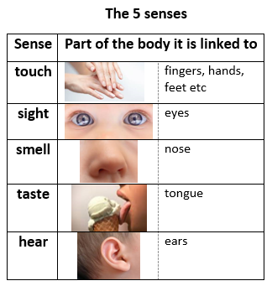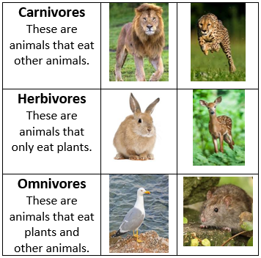

Knowledge/skills

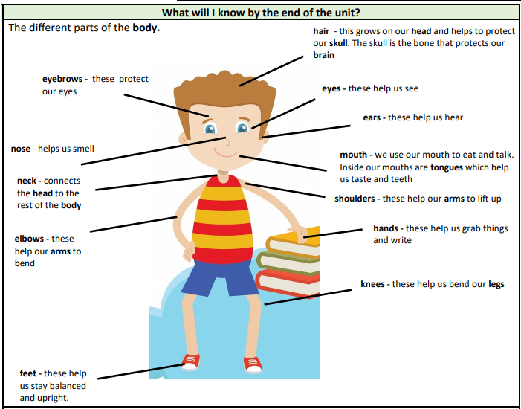

|  |  |  |
| --- | --- | --- |
| Question 1: An animal that  gives birth to live young and  has hair or fur is called a… | Start of  unit: | End of  unit: |
| mammal |  |  |
| fish |  |  |
| insect |  |  |
| reptile |  |  |

|  |  |  |
| --- | --- | --- |
| Question 2: Which of these is **not** a suitable pet? | Start of  unit: | End of  unit: |
| dog |  |  |
| rabbit |  |  |
| rhinoceros |  |  |
| hamster |  |  |

|  |  |  |
| --- | --- | --- |
| Question 3: What do fish, reptiles and birds have in common? | Start of  unit: | End of  unit: |
| they all have wings |  |  |
| they can all breathe underwater |  |  |
| they all lay eggs |  |  |
| they all have feathers |  |  |

|  |  |  |
| --- | --- | --- |
| Question 4: Match these to the groups they belong to: | Start of  unit: | End of  unit: |
|  |  |  |

|  |  |  |
| --- | --- | --- |
| Question 5: Match the types of animals to their description: | Start of  unit: | End of  unit: |
|  |  |  |

|  |  |  |
| --- | --- | --- |
| Question 6: Which of these might you find on a face? | Start of  unit: | End of  unit: |
| eyes |  |  |
| mouth |  |  |
| knees |  |  |
| hands |  |  |
| nose |  |  |

|  |  |  |
| --- | --- | --- |
| Question 7: What do elbows do? | Start of  unit: | End of  unit: |
| Help our legs bend |  |  |
| Help our arms bend |  |  |
| Help us walk |  |  |
| Help us taste |  |  |

|  |  |  |
| --- | --- | --- |
| Question 8: Which of these protects our head? | Start of  unit: | End of  unit: |
| arms |  |  |
| mouth |  |  |
| hair |  |  |
| elbow |  |  |

|  |  |  |
| --- | --- | --- |
| Question 9: What does the neck do? | Start of  unit: | End of  unit: |
| Connects the legs to the body |  |  |
| Connects the hands to the feet |  |  |
| Connects the feet to the legs |  |  |
| Connects the head to the body |  |  |

|  |  |  |
| --- | --- | --- |
| Question 10: Match the senses to the parts of the body that help us do them. | Start of  unit: | End of  unit: |
|  | | |